2019 Team Record Sheet for Fall League Playoffs

Club: _______________________________________
League: 14B 14G 12B 12G
Team Number: 1 2 3 4
(For example: Congdon #4)
Record: W_______ L_______ T______

 | Date/Time | Site | Opponent | Your  Score | Opponent’s Score | Win/Loss/Tie
1.
2.
3.
4.
5.
6.
7.
8.
9.
10.

Coach’s Name: _______________________________ ____________ Phone Number: _______________________
(Print Please)

Email Address: ________________________________________________________________________________

This sheet must be mailed, e-mailed, or faxed to AYSA by:

U12 Teams – Due Friday, September 6 at NOON
U14 Teams – Due Tuesday, September 10 at NOON

3501 Grand Avenue
Duluth, MN 55807
Fax: 218-624-1759
info@arrowheadsoccer.com

If your team record is not turned in by the above deadlines, your team will be seeded where we deem appropriate.

AYSA FALL LEAGUE PLAYOFFS
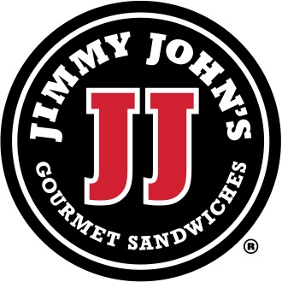
Sponsored by Jimmy John’s

Each U12 and U14 team in Fall League will be guaranteed two playoff games with the possibility of qualifying for a Final Four. In very small leagues, a championship game may be played in lieu of a Final Four, at AYSA’s discretion.

Teams are seeded by season win/loss record. Teams with a better win/loss record will be seeded higher. In order to seed your team for playoffs, coaches will need to turn in your won/lost record by:

U12 Teams – Due Friday, September 6 at NOON
U14 Teams – Due Tuesday, September 10 at NOON

Please fill out the form on the reverse side and return it to the AYSA office by Noon on the due date. The form will also be on our website 10 days prior to the due date.
Teams do not have to take part in playoffs. If your team will not participate in playoffs, you must notify AYSA by September 6 for U12 teams and by September 10 for U14 teams.

You can send us your team record sheet via:
E-mail: info@arrowheadsoccer.com
Fax: 218-624-1759
Drop the form off at our office: Wheeler Fieldhouse, 3501 Grand Avenue, Duluth
We will not accept team record reports by phone.

Please put the information into a format that is reasonably close to the form.

If you need to reschedule games and you want them to count toward your playoff seeding, those games need to be completed before your age groups cutoff date. Please include game scores, as we use these as tiebreakers for seeding teams. If you do not include game scores, your team will likely be seeded lower than if you include those scores. Playoff schedules and rules will be posted on the AYSA website (www.arrowheadsoccer.com) about five days prior to first round games. Coaches will be asked to call in scores of first round playoff games immediately after the game is played. You will not need to call in Final Four games scores.
Thank you to our Playoff Sponsor Jimmy John’s!

