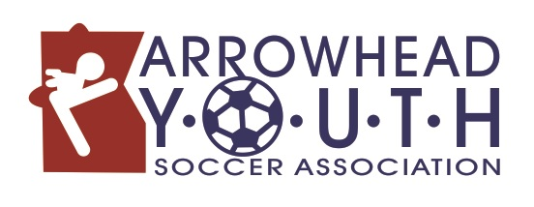
Arrowhead Youth Soccer U16 League
Play Up Player Form

U16 League Team: _____________________________________________________________

The following Fall League players will be playing up on this team for the game on ________________.
DATE

Name | Fall League Club/Team

I certify that the above named players are registered for Arrowhead Youth Soccer’s Fall League.

U16 League Coach Name: ________________________________________________________

U16 League Coach Signature: ______________________________________________________

Center Referee Signature: _______________________________________________________________

Coaches, please complete this form and hand it to the referee prior to any game in which your U16 League teams use play up players.
All play up players must be registered for Arrowhead Youth Soccer’s Fall League program.

